Peer-to-Peer (P2P) campaigns are a great way to build engagement with your constituents and raise funds for your organization. Below are some suggestions to consider when planning, promoting, and conducting your campaign using DonorView. Please note this outline is intended as a guide, not specific requirements. There are also checklists included at the end of this guide.
- Planning Stage
- Training Videos & Support Articles - Before undertaking the planning of the P2P campaign, be sure you have watched the training videos and reviewed the support articles listed below.
  - Peer to Peer Fundraising - https://vimeo.com/197190005/45f2587426
  - Peer to Peer Event - https://vimeo.com/763864527/4ab179c72a
  - Frequently Asked Questions For P2P Campaigns Support Article – https://support.donorview.com/en/support/solutions/articles/9000236878-faqs-for-peer-to-peer-campaigns
  - General Peer to Peer Support Articles - https://support.donorview.com/en/support/solutions/folders/9000161307
  - Managing the Portal and Portal Users Support Articles - https://support.donorview.com/en/support/solutions/folders/9000175741
- Determine the type of event
- There are two types of P2P campaigns, Event and Non-Event campaigns.
  - P2P Non-Event campaigns
    - These campaigns are raising funds for your organization but do not include any specific event associated with them.
    - Funds raised can go to general funds or for a specific project or program. Things like adopt-a-classroom, capital building projects, or scholarships are examples of project or program directed campaigns.
  - P2P Event campaigns
    - Event campaigns are linked to an event via the Event Settings Tab.
    - These campaigns are raising money for your organization, but the participants will also engage in an event as part of the fundraising.
    - 5K races, triathlons, marathons, walk, read, hike or bike-a-thons, golf, fishing, bowling, and other sporting tournaments, and dance competitions can all be examples where a P2P campaign is linked to an event.

  - P2P Event Terminology
    - Team Leader – if teams are formed, the team leader can manage their personal fundraising page as well as the team fundraising page.
    - Participant fundraiser – a participant who is fundraising and has their own fundraising page.
    - Participant – for events, this person is only participating in the event and does not have a personal fundraising page.
    - Dependent participant – for events, this person is participating in the event but will not have a constituent profile record created. This is most often used for children.
- Teams
  - Teams are not required for DonorView P2P campaigns and can be disabled if desired.
  - If teams are enabled, you can place a cap on the maximum number of participants on each team.
  - If you set a maximum number of participants for a team, once that number is reached, no new participant fundraisers or other participants can join that team.
- Defining goals for event
- Establish goals for the event including:
  - Number of teams (if applicable) and max team size
  - Number participant fundraisers
  - Fundraising goals for participants/teams
  - Event specific goals
    - Non-participant fundraiser participation
    - Sponsorships
  - Expenses
- Defining your goals will help you to:
  - Identify where you should focus your resources
  - Finalize your budget
  - Establish targets for the number of participation invites and sponsorship requests based on projected response rates
    - If past response rates were around 25% and you have a goal of 100 participants, you’ll need to send out at least 400 invitations to reach your goal.
    - From DonorView, you can create reports to identify the best prospects for your invitations based on geographical location, historical giving, and past event attendance.
    - Historical participation and giving history can also help you identify the best prospects for potential team leaders.
- Organize a committee
- A committee of volunteers to help plan and host the event can help alleviate the staff time
- Ensure you have roles and responsibilities outlined for each committee member. Some recommended roles include:
  - Tech support – some participant fundraisers may be less comfortable with technology and will need assistance creating and promoting their fundraising pages.
  - Team organizer support – Allowing team leaders to have a single point of contact for assistance will help them to get questions answered quicker and more accurately.
  - Marketing/promotions – P2P campaigns typically take place over several week or months and a comprehensive marketing strategy is necessary to maintain participation and support.
  - Sponsorship solicitors – this person or team can visit with potential sponsors to share the benefits of their support.
  - Volunteer coordinator (for events) – a key role for the event to coordinate all the volunteer training and activities at the event.
- Creating a theme
- Themes make it easier for designing promotional material and advertising.
- A unique theme can make the event more enticing and attract new participants.
- Determining scope and schedule
- Set boundaries for the scope of your event to keep the committee, teams, and participants focused and help you stay on task.
- Be sure to establish a schedule with activities listed with due dates and who is responsible.
- Incorporate goal tracking and regular meetings to ensure progress is on track.

- P2P Sponsorships
  - Sponsorships can be offered for Stand-Alone campaigns and P2P Events.
  - P2P campaign fundraising pages can include messaging and images to help promote any sponsorships for P2P campaigns.
  - You can link sponsorships to event levels (if applicable), link them to manually entered donations, and create a list of tasks using the Sponsorships feature in the Fundraising Module.
  - This will allow you to create tasks and follow-ups to manage the deliverables associated with those sponsorships.
  - You can see more about sponsorships in this video https://vimeo.com/850688116/fdfeda0782 and we’ve just released a new feature to assign follow-ups and you can read more about this in the knowledgebase article here: https://support.donorview.com/support/solutions/articles/9000217093-how-do-i-assign-tasks-for-sponsorship-follow-ups
  - If sponsorships include any admission to the event, including all your ticket levels and sponsorships on the same event page will make managing attendees much easier since only one event can be shown at a time on the Event Attendance grid.

- Develop your Marketing Strategy
- Determine what methods and channels you’ll be using to market your event and P2P campaign.
- Ensure your marketing strategy is in line with your budget.
- Within DonorView, you can utilize:
  - The email marketing features to send out colorful invitations that include direct links to your pages, whether they are for the event sign up or a stand-alone campaign.
  - The mail merge features including envelopes and letters for paper mail invitations and sponsorship solicitations.
  - The URLs generated from each page to link or embed on your organization’s website and to share on social media.
  - The QR codes that are generated on each page for inclusion in social media, advertising, brochures, posters, and other invitations.
  - Text to URL codes identified for event pages can also be promoted and included in marketing.
  - Direct text messaging allows you to send personalized texts to constituents and can even include a brief video message.
  - The calendar widget in the Events Page grid.
    - You can customize the calendar and get the URL to share on your website under the actions menu.
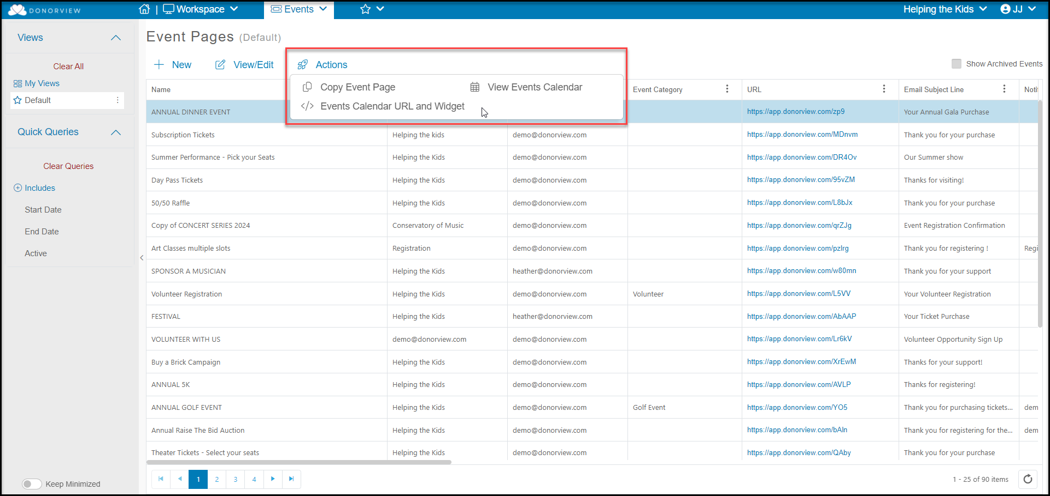
    - Be sure that you have your event set to show on the calendar by selecting the toggle on the Event Setting Tab to “Yes.” You can choose to show the “Event Start & End Date” for single day events or “Use Ticket Level Available Days” for multi-day events.
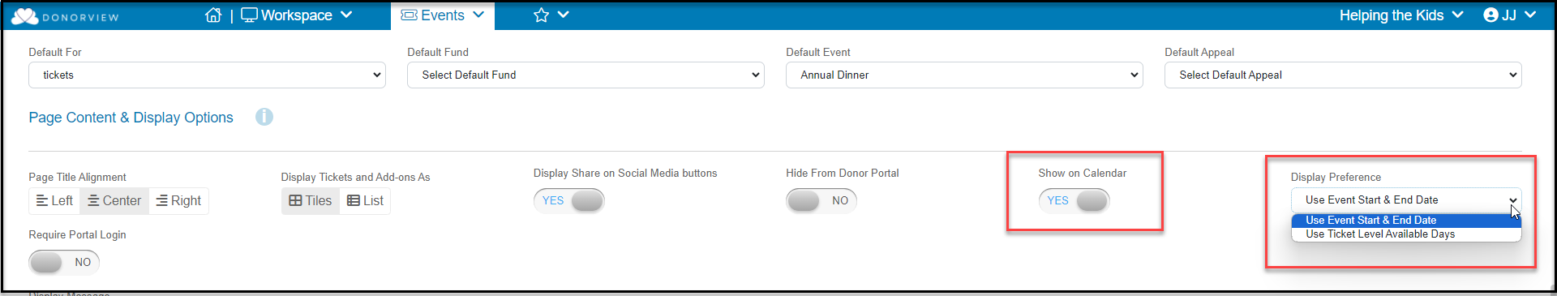

- Participant Fundraiser Recruitment
    - Recruiting fundraising participants is key to a successful P2P campaign.
    - Spend time creating impactful messaging to attract participants who share your organization’s values and passion for your mission.
    - Leverage the power of social media to share your message.
    - Besides the intrinsic benefits of supporting your organization, you can also offer prizes, recognition, private parties, and other incentives to participant fundraisers.
    - Consider creating videos to promote and showcase how the program works.
    - Demonstrate the support participants will receive by creating fundraising toolkits and guides to provide instructions and guides for the campaign.
    - See support article “Are There Guides to Share with Participant fundraisers?” to find examples you can customize for your own organization.

- P2P Process for Stand-Alone Campaigns
  - If there is no event, all the participant fundraiser participation will be through the Donor Portal.
  - Step 1 – Build the P2P campaign page
    - Settings
      - The title you enter will be included on every fundraising page.
      - Establish an overall target goal to populate widgets.
      - You can leave the event date ranges blank since this campaign is not linked to an event.
      - The Fundraising Begin and End date is the date range that the participant fundraiser’s pages are viewable to the public.
      - The Active to Participant Begin and End date is the date range that the pages will be visible to the participant fundraisers in their portal account. Outside this date range, participant fundraisers will not be able to modify or view their pages.
    - Widgets
      - On the Preview & Publish tab there are several built in widgets generated automatically.
      - You can also create a custom widget for the overall goal.
    - Thank you message
      - The Thank You message goes to all donors to any of the fundraising pages.
      - You can customize message and include links back to you website where you can share your progress widgets.
  - Step 2 – Share the page with potential participant fundraisers and/or team leaders
    - Use the URL Link, text code, or QR code
    - Send invitations via emails and texts to constituents
    - Share on social media
  - Step 3 – Support Participant fundraisers
    - Be prepared to provide support to your participant fundraisers if they have trouble creating or updating their pages.
    - Use milestones and badges to keep your participant fundraisers engaged.
    - Ensure that you have a communications plan developed to stay in touch with your participant fundraisers.

- P2P Process for Events
  - Follow the same Step 1 as above to create your campaign page.
  - Step 2 – Create the Event Page
- Link your event to the P2P campaign in the Settings tab.
    - Determine if you will allow participants or dependent participants for your event.
    - Determine if you will require a ticket purchase to become a participant fundraiser.
    - Customize the labels on the page as desired.
- In the Event Setup tab, determine what ticket levels you will be offering for your event.
- Note that there are many options available for event tickets including:
    - Early bird or late registration pricing using the “Set Active Level Dates” feature.
    - Restricting levels to members only using the “Members Only” feature.
    - Allowing just a deposit for a purchase, which is helpful for some larger sponsorships where the registrant may prefer to mail a check. You can learn more about the new deposit feature here: https://support.donorview.com/support/solutions/articles/9000235798-event-level-deposits
- Add-ons
- Add-ons are items that do not include admission to the event. They include things like:
  - T-shirts, hats, commemorative win glasses, and other physical items.
  - Advertising in the program, tee hole signs at golf tournaments, or banners at the event.
  - Raffle, helicopter ball drop, or game tickets.
  - Sponsorships that do not include admission.
- You can limit the quantity of add-on items that are available, for example there may only be 100 raffle tickets available for sale.
- Add-on purchases do not show in the event attendance grid, so if you need a name associated with who is using that add-on to show in the event attendance grid, make it a ticket level instead.
- If you are selling ticket levels that include admission for more than one person, or if ticket levels are being purchased by companies, use the Attendee Info tab to collect the names and answers to any special questions.
- Attendee info questions can include things like:
  - Meal preferences
  - Seating preferences
  - Handicap (for golf tournaments)
  - T-shirt size
  - Age group (for 5Ks and runs)
  - Allergies
  - Special needs
- The answers to these attendee questions will be shown in the Event Attendance grid.
- See more about the Event Attendee Info tab in this video https://vimeo.com/732471168/ab2a288419
- If you plan to use the table assignments or event assignments feature, be sure to turn this on in the Attendee Info tab at the bottom of the page. Activating this does not require that you use it.
  - Step 3 – Share the event page
    - Instead of sharing the P2P campaign link, you will share the Event page link instead.
    - Use the URL Link, text code, or QR code
    - Send invitations via emails and texts to constituents
    - Share on social media
    - Participant fundraisers and other types of participants will select the first box to Become a Participant fundraiser (or whatever label you have added – Race or Start a Team example is shown below.)
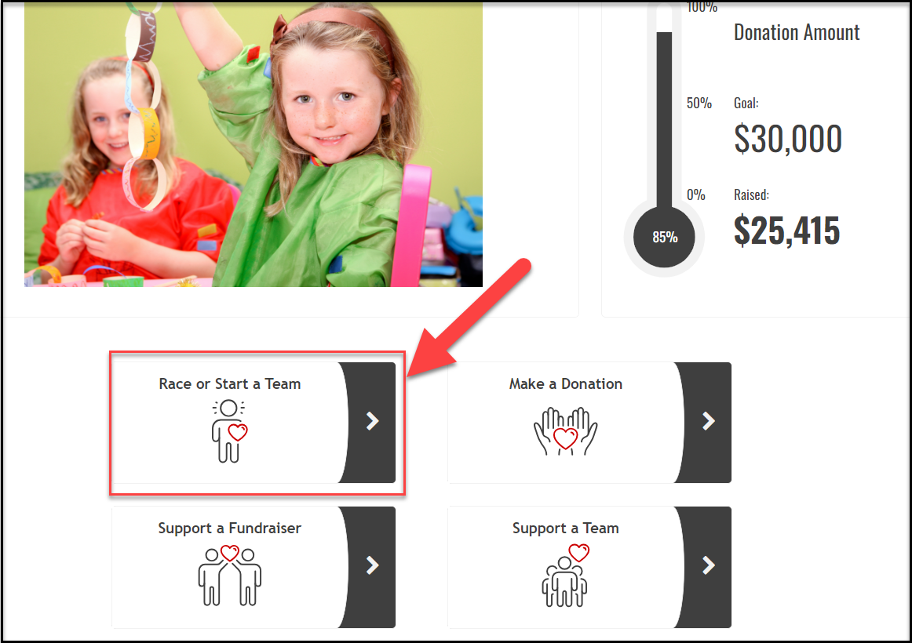
  - Step 4 – Support Participant fundraisers
    - Be prepared to provide support to your participant fundraisers if they have trouble creating or updating their pages.
    - Use milestones and badges to keep your participant fundraisers engaged.
    - Ensure that you have a communications plan developed to stay in touch with your participant fundraisers.

- Tracking Sales and Participation
- Set up milestones to track progress on your ticket and sponsorships sales and P2P teams/participant fundraisers.
- You can see all your event sales in the Events Summary grid, as well as the individual transactions on the Gifts grid.
- The P2P Dashboard has two views, a summary view and a detail view.
  - The summary view provides information ONLY for individual participant fundraisers and teams that have at least one transaction associated with their page.
  - For free events, note that the registration, even though it was $0, it will display as a $0.00 total funds raised for that participant fundraiser’s page.
  - The detail view will show each individual donation (and/or the original event purchase) for each participant fundraiser or team’s page.
- Make adjustments to your marketing, promotion, and solicitation strategies as needed.
- Create check-in points with fundraising participants to provide encouragement along the way, especially if they are falling short of goals.

- Communications
- P2P Participant Fundraisers
  - You can see a list of participant fundraisers on the P2P Dashboard.
  - The Summary view will only show those that have a transaction related to their pages, so if you want to include all participant fundraisers, you will need to go to the Detail view instead.
  - You can create email lists or send direct emails and texts using the Actions menu.
  - If using the Detail view, only the participant fundraisers are included in the communications, not the individual donors.
- Event Auto-Reminders
- You can establish a variety of auto-reminders for your event. This video provides an overview of this feature https://vimeo.com/722260141/aa62e84e84
- Auto-reminders can be sent to specific levels, so special messages can be directed to sponsors with a different message sent to single ticket holders.
- Auto-reminders can be linked to the purchase date, before the event date, and after the event date.
- You can also choose any specific date and time to send your message.
- Note that event auto-reminders go to event registrants, not all attendees. You can send messages to attendees from the Event Attendance grid.
- Milestones & Badges
  - Setup milestones for keeping your participants engaged.
  - Create a variety of milestones so that you can recognize effort as well as achievement.
    - For example, receiving a badge for sending 5 emails recognizes effort, even if no donations have been received yet.
    - If using teams, you can also create team goals so that those accomplishments can be recognized and seen by all the team members.
  - You can create and upload your own badges to use on the participant fundraiser’s pages and upload them.
    - Images you create should be in a square format, less than 1 MB in file size.
    - You can also use a badge from the library by clicking on the blue Select from Library button.
    - The icons included are 120 x 120 pixels.
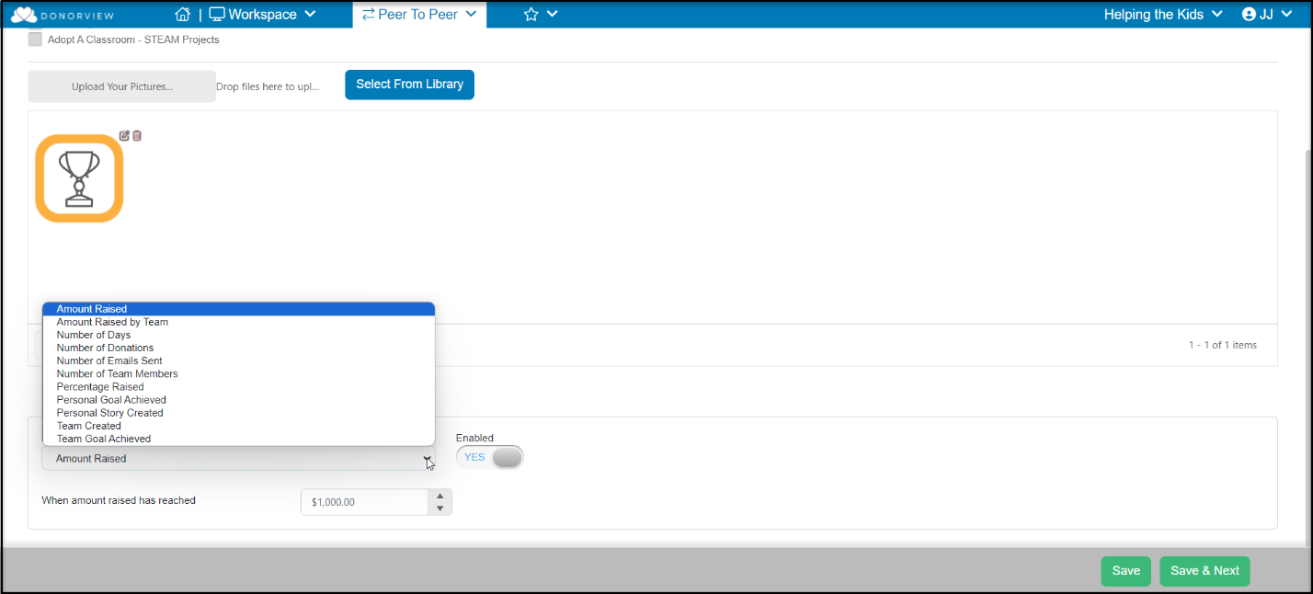
  - Select the appropriate trigger you want to use for your badge and identify the criteria.

  - The Number of Days choice allows you to send notices when a participant fundraiser is not meeting goals.
    - This feature requires an event date established in the P2P Campaign Setting tab.
    - The send trigger is linked to the number of days before or after the event date.
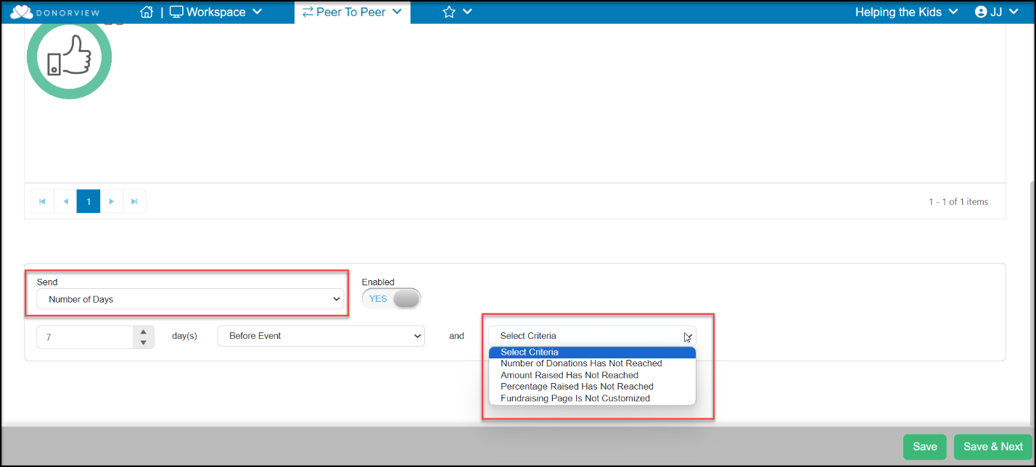
  - Name your milestones with a recognizable name so that you can use them for reporting on the P2P Dashboard.
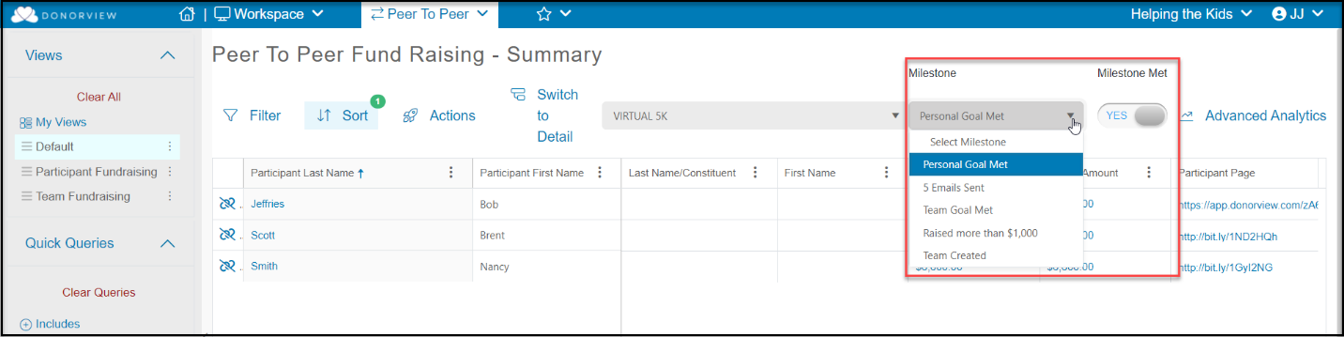

- Hosting the P2P Event
For a campaign that is linked to an event, use the instructions provided in the Event Management Outline and Checklist found here for more details on hosting and event. https://support.donorview.com/en/support/solutions/articles/9000236150-event-management-outline-checklist

- Post Event
- Collecting pledge payments
  - Pledges will be identified on the P2P Dashboard under the Pledge column.
  - The pledges will also be recorded in the Gifts and Pledges grid.
  - Attendees with payments due can be contacted with a direct email, text, or by using the mail merge template letters from the Gifts or Pledges grid.
- Thanking Participant Fundraisers
  - Your P2P Dashboard summary grid will show you all the participants and teams who successfully raised money.
  - You can create email lists and campaigns and send texts and direct emails using the Actions menu to thank them for their participation.
- Thanking attendees and sponsors
- Your Event Attendance grid will show who actually attended your event.
- You can send a text, direct email, or make an email list to let your attendees know your final numbers and thank them for making the event a success.
- Your Event grid will identify your list of sponsors so you can contact them with their post-event thank you message.
- Recording volunteer hours
  - If you did not set up automatic hours via a volunteer event, be sure to record the hours for your volunteers in DonorView.
  - Volunteers can also receive a special thank you for their service.

P2P Checklist

Planning Stage
Activity | Responsible | Target  Date | Completed Date | Notes
Determine type of event
Establish goals for the event
Form the event committee
Choose the event theme
Determine the event scope
Create & distribute the schedule
Sponsorships
Activity | Responsible | Target  Date | Completed Date | Notes
Determine sponsorship offerings
Set up sponsorship tasks
Identify potential sponsors
Determine sponsorship solicitors
Marketing Plan
Activity | Responsible | Target  Date | Completed Date | Notes
Determine marketing channels
Create marketing messaging
Develop marketing timeline
Determine which DV tools to utlize
Participant Fundraiser Recruitment & Campaign Creation
Activity | Responsible | Target  Date | Completed Date | Notes
Determine prizes & recognition
Identify prospective fundraisers
Indentify prospective team leaders
Build P2P Campaign pages
Build Event page (if applicable)
Create fundraiser tool kit
Send invitations to participate

P2P Checklist (Continued)
Tracking & Communications
Activity | Responsible | Target  Date | Completed Date | Notes
Setup email lists for participants
Add progress widgets to website
Create event auto-reminders
Create milestons & badges
Create check-in points for participants
Pre-Event (Event linked P2P Campaigns Only)
Activity | Responsible | Target  Date | Completed Date | Notes
Order cc swipers
Download DV Connect app
Set up attendee communications
Update event attendee information
Set up new users & mobile app
Assign & schedule volunteers
Train volunteers
Verify wi-fi & cell service at venue
Create equipment list
Hosting The Event (Event Linked P2P Campaigns Only)
Activity | Responsible | Target  Date | Completed Date | Notes
Charge swipers
Test laptops, iPads & iPhones
Set up check in/check out area
Record donations/pledges
Post Event
Activity | Responsible | Target  Date | Completed Date | Notes
Collect remaining payments
Send fundraisers thank you’s
Send attendee thank you’s
Send sponsor thank you’s
Record volunteer hours

